FORECASTING AND OPTIMIZATION FRAMEWORK FOR RENEWABLE ENERGY SYSTEMS
By
Harsh Pandey (22BSM023)

Supervisor(s):
Dr. Sachin Kumar Saxena


Discipline: Bachelor of Technology (B.Tech)

INDIAN INSTITUTE OF INFORMATION TECHNOLOGY, DESIGN AND
MANUFACTURING JABALPUR

2026

ACKNOWLEDGEMENTS

I would like to express my sincere gratitude to my project supervisor Dr. Sachin Kumar Saxena for their continuous guidance and support throughout the course of this Bachelor Project. Their valuable suggestions and technical insights helped in shaping the direction of this work.

Finally, I would like to acknowledge the researchers whose work on digital twin technology and wind power forecasting provided the foundation for this study.
Harsh Pandey (22BSM023)

6th June, 2026

DECLARATION OF ORIGINALITY

I hereby declare that this Bachelor Thesis Project report titled “Forecasting and Optimization Framework for Renewable Energy Systems” is my original work carried out under the supervision of my project guide. This work has not been submitted elsewhere for any degree or diploma.

All sources of information used in this report have been properly cited.

ABSTRACT

Renewable energy forecasting plays a critical role in ensuring reliable operation of modern power systems. Among renewable energy sources, wind power exhibits high variability due to changing meteorological conditions. Accurate forecasting of wind power generation is therefore essential for efficient power system planning, energy dispatch, and grid stability.

This project presents the development of a Forecasting and Optimization Framework for Renewable Energy Systems using deep learning models and data fusion techniques. Instead of relying on a single predictive model, the proposed approach integrates multiple forecasting models acting as digital twins of the wind power system.

Four deep learning models were implemented as digital twins: Long Short-Term Memory (LSTM), Gated Recurrent Unit (GRU), LSTM-CNN hybrid model, and GRU-CNN hybrid model. These models generate independent forecasts which are then combined using two fusion methods: Dynamic Preference Method and Dempster-Shafer Evidence Fusion.

An interactive visualization dashboard was developed to analyze model predictions, evaluate performance metrics, and observe dynamic fusion behavior. Experimental results show that the Multi Digital Twin framework improves forecasting accuracy compared to individual models.

The proposed system demonstrates the potential of digital twin technology for renewable energy forecasting and intelligent energy management systems.

Keywords: Multi-Digital Twin, Wind Power Forecasting, Deep Learning, LSTM, GRU, Dynamic Fusion, Renewable Energy Forecasting.

CHAPTER 1: INTRODUCTION
1.1 Problem Definition and Motivation
The global transition toward sustainable energy systems has resulted in large-scale integration of renewable energy sources such as solar and wind power. Renewable energy plays a vital role in reducing greenhouse gas emissions and supporting sustainable development goals. However, renewable power generation is highly dependent on environmental conditions and therefore exhibits significant variability and uncertainty.
Wind power forecasting is an essential requirement for maintaining power system reliability and efficient grid operation. Accurate forecasting enables power system operators to balance electricity supply and demand, plan energy dispatch, and reduce operational costs.
Traditional forecasting systems often rely on a single predictive model. These approaches may not capture complex patterns in wind data and often suffer from reduced accuracy when environmental conditions change.
To address these challenges, digital twin technology has emerged as a promising approach for modeling and predicting the behavior of physical systems in real time. A digital twin is a virtual representation of a physical system that receives data from sensors and uses simulation or machine learning models to analyze system behavior.
However, most existing digital twin frameworks rely on a single digital twin model, which may limit adaptability and forecasting accuracy. The concept of Multi-Digital Twin (MDT) has been proposed to overcome these limitations by integrating multiple digital twins and combining their predictions through data fusion techniques.
This project focuses on developing a multi-digital twin framework that integrates several deep learning models to improve wind power forecasting accuracy.
1.2 Literature Survey
Several studies have explored digital twin technology and its applications in renewable energy systems. Digital twins enable real-time monitoring, prediction, and optimization of physical processes by creating virtual models that replicate system behavior.
Recent research has focused on applying digital twin frameworks for renewable energy forecasting. The research paper “Research on Multi-Digital Twin and its Application in Wind Power Forecasting” introduces the concept of combining multiple digital twin models to improve prediction performance. The proposed framework integrates several neural network models including LSTM and GRU architectures to simulate the behavior of wind power systems.
The study demonstrates that combining multiple digital twins through dynamic fusion methods can improve forecasting accuracy compared to individual models.
Other studies have explored digital twin applications in energy systems including building energy forecasting, photovoltaic system monitoring, and smart grid management. These works highlight the importance of integrating forecasting models with digital twin architectures to improve system reliability and operational efficiency.
Despite these advancements, many renewable energy forecasting frameworks still operate independently from optimization and control systems. Therefore, integrated frameworks that combine forecasting, digital twins, and adaptive control mechanisms remain an active area of research.
1.3 Objectives and Scope
The main objectives of this project are:
- To study digital twin technology and its applications in renewable energy systems.
- To implement deep learning models for wind power forecasting.
- To develop a multi-digital twin framework integrating multiple forecasting models.
- To implement data fusion methods for combining predictions from multiple digital twins.
- To evaluate forecasting performance using standard error metrics.
Scope of the study:
The project focuses on simulation-based forecasting using historical wind power datasets and machine learning models. Real-time hardware integration and cybersecurity aspects are beyond the scope of this work.
1.4 Report Layout
The report is organized as follows:
Chapter 1 - introduces the research problem, motivation, literature review, and objectives of the project.
Chapter 2 - describes the methodology, experimental setup, algorithms, and software tools used for implementing the multi-digital twin framework.
Chapter 3 - presents the results obtained from the implemented models and provides analysis and discussion of the forecasting performance.
Chapter 4 - summarizes the overall work, highlights the conclusions derived from the investigation, and outlines future research directions.

CHAPTER 2: METHODOLOGY / INVESTIGATION
2.1 Overview of the Proposed System
The proposed system implements a Multi-Digital Twin (MDT) framework for wind power forecasting using deep learning models and dynamic fusion techniques.
The goal of the system is to improve prediction accuracy by combining the strengths of multiple forecasting models instead of relying on a single model.
The overall workflow of the system consists of the following stages:
- Data acquisition and preprocessing
- Digital twin model development
- Prediction generation
- Fusion of model predictions
- Visualization and performance evaluation
Each component of the system contributes to the final forecasting output.
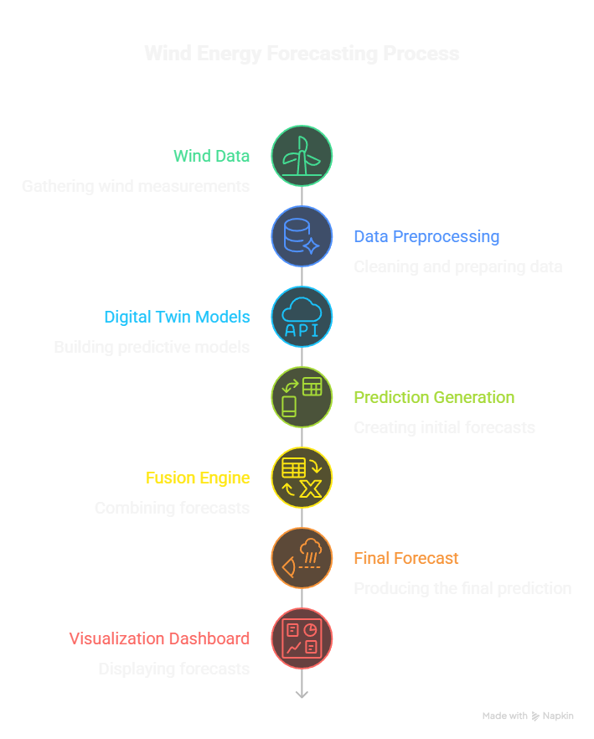
Figure 2.1 Overall Workflow of the MDT Forecasting Framework.

2.2 Data Acquisition and Preprocessing
Wind power forecasting relies on time-series datasets containing meteorological and power
Typical features used for forecasting include:
Feature | Description
Wind Speed | Primary variable influencing wind power
Temperature | Affects air density
Pressure | Impacts turbine efficiency
Humidity | Influences atmospheric conditions
Historical Power Output | Previous generation data
These features are collected from wind farm monitoring systems or publicly available datasets.
Data Preprocessing Steps
Before training the forecasting models, the dataset must undergo several preprocessing steps.
1. Handling Missing Data
Sensor datasets often contain missing or corrupted values. These values were replaced using interpolation techniques to maintain data continuity.
2. Normalization
Machine learning models require normalized input data. Therefore, Min-Max scaling was applied:
$$X_{norm}=\frac{X-X_{min}}{X_{max}-X_{min}}$$
Normalization ensures that all features have comparable numerical ranges.
3. Sliding Window Generation
Wind forecasting is a time-series problem. To train the neural network models, historical data is converted into input sequences using a sliding window technique.
Example:
Input Window → Output
[ t1, t2, t3, t4 ] → t5
[ t2, t3, t4, t5 ] → t6
This allows the model to learn temporal dependencies between observations.
Time Series Data
t1 t2 t3 t4 t5 t6 t7
Input: [t1 t2 t3 t4] → Predict t5
Input: [t2 t3 t4 t5] → Predict t6
Input: [t3 t4 t5 t6] → Predict t7

Figure 2.2 Sliding Window Data Preparation
2.3 Digital Twin Model Development
In the MDT framework, each forecasting model acts as a digital twin of the wind power system.
A digital twin is a virtual model capable of simulating the behavior of the physical system.
Four models were implemented as digital twins:
Digital Twin | Digital Twin Model
DT1 | LSTM
DT2 | GRU
DT3 | LSTM-CNN
DT4 | GRU-CNN
2.4 LSTM Model
Long Short-Term Memory networks are designed to handle sequential data and capture long-term dependencies.
The LSTM architecture shown in Figure 2.3 consists of three main components:
- Input Layer
The input layer receives the time-series data consisting of multiple historical observations of wind power and meteorological variables.
- LSTM Layers
Multiple LSTM units process the sequential data. Each LSTM unit contains internal gates that control information flow:
  - Forget gate
  - Input gate
  - Output gate
These gates allow the network to retain important information from previous time steps while discarding irrelevant data.
- Linear Output Layer
The final hidden representation generated by the LSTM layers is passed to a fully connected linear layer which produces the predicted wind power output.
The ability of LSTM networks to capture long-term temporal dependencies makes them highly suitable for wind power forecasting applications.

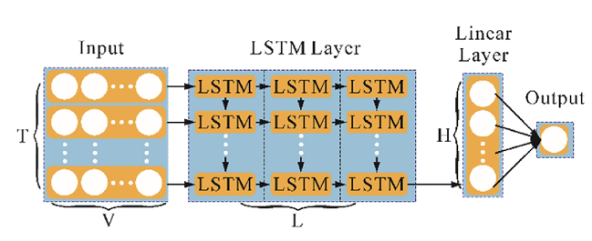
Fig 2.3 Architecture of LSTM wind power forecasting model.

2.5 GRU Model
The Gated Recurrent Unit (GRU) is a simplified variant of LSTM that reduces computational complexity while maintaining high prediction accuracy.
as illustrated in Figure 2.4, the GRU model consists of the following components:
- Input Layer
The input layer receives sequential wind power data similar to the LSTM model.
- GRU Layers
GRU networks contain two gates:
  - Reset gate
  - Update gate
These gates regulate how much of the previous information should be retained or forgotten.
- Linear Layer
The final hidden state generated by the GRU layers is passed through a linear layer to produce the final wind power forecast.
Compared with LSTM networks, GRU models require fewer parameters and train faster, making them suitable for real-time forecasting systems.
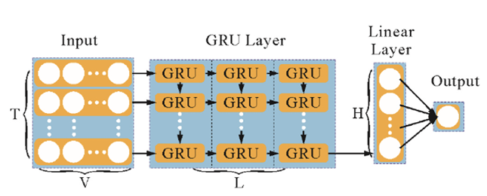
Fig 2.4 Architecture of GRU wind power forecasting model.
2.6 LSTM-CNN Hybrid Model
Hybrid deep learning models combine different neural network architectures to improve prediction performance. The LSTM-CNN model integrates convolutional neural networks with LSTM layers to capture both spatial and temporal patterns in wind data.
The architecture shown in Figure 2.5 includes the following components:
- Input Layer
The model receives time-series wind power data.
- LSTM Layer
The LSTM layer processes temporal dependencies and extracts sequential patterns.
- 1D Convolutional Layer (CNN)
The convolutional layer extracts local patterns from the feature sequences.
- ReLU Activation Function
The Rectified Linear Unit introduces non-linearity into the model and improves learning capability.
- Max Pooling Layer
The pooling layer reduces dimensionality and selects the most important features.
- Fully Connected Linear Layer
The extracted features are passed to a linear layer that generates the final forecast output.
This hybrid architecture allows the model to capture both temporal dependencies and local feature patterns, improving forecasting accuracy.
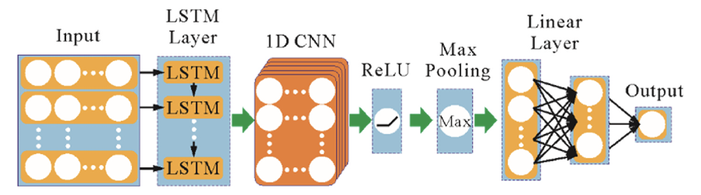
Fig 2.5 Architecture of LSTMCNN wind power forecasting model.
2.7 GRU-CNN Hybrid Model
The GRU-CNN hybrid model combines GRU networks with convolutional neural networks to improve feature extraction and forecasting performance.
As shown in Figure 2.6, the architecture includes the following components:
- Input Layer
The model receives time-series wind power input data.
- GRU Layer
GRU layers capture temporal dependencies in the sequential data.
- 1D Convolutional Layer
The convolutional layer extracts spatial features from the hidden representations.
- ReLU Activation Function
The activation function introduces non-linear transformations.
- Max Pooling Layer
The pooling operation reduces dimensionality and highlights the most significant features.
- Fully Connected Linear Layer
The final output layer produces the predicted wind power value.
The GRU-CNN model benefits from the efficient sequential learning of GRU networks and the feature extraction capability of CNN layers.
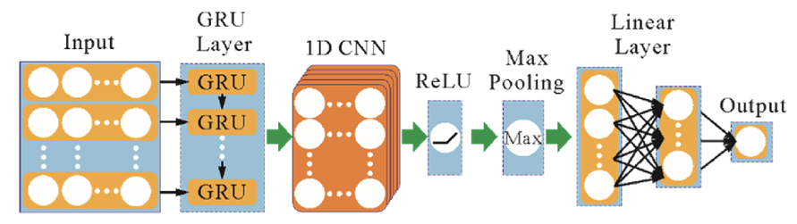
Fig 2.6 Architecture of GRUCNN wind power forecasting model.
2.8 Multi-Digital Twin Fusion Mechanism
In the proposed Multi-Digital Twin (MDT) framework, multiple forecasting models operate simultaneously as independent digital twins of the wind power system. Each digital twin processes the same historical wind power dataset and produces its own prediction for future power generation.
Since different machine learning models capture different patterns in time-series data, the predictions produced by each digital twin may vary. For example, recurrent neural networks such as LSTM and GRU are effective at capturing long-term temporal dependencies, while hybrid models such as LSTM-CNN and GRU-CNN are capable of extracting both spatial and temporal features.
Instead of relying on a single model, the MDT framework integrates predictions from multiple models using a fusion mechanism. The purpose of the fusion mechanism is to combine the strengths of individual models and generate a more accurate and reliable forecast.
The general fusion process involves the following steps:
- Generate predictions from each digital twin model.
- Evaluate the performance of each model.
- Combine the predictions using a fusion algorithm.
- Produce the final forecasting output.
The general fusion equation can be expressed as:
$$P_{final}=F\left(P_{1},P_{2},P_{3},P_{4}\right)$$
Where:
P1 = prediction from LSTM
P2 = prediction from GRU
P3 = prediction from LSTM-CNN
P4 = prediction from GRU-CNN
where $F(⋅)$represents the fusion function that combines predictions from multiple digital twins.
The fusion mechanism improves forecasting accuracy by reducing the influence of errors produced by individual models. By combining multiple predictions, the MDT framework can produce more stable and robust forecasting results.
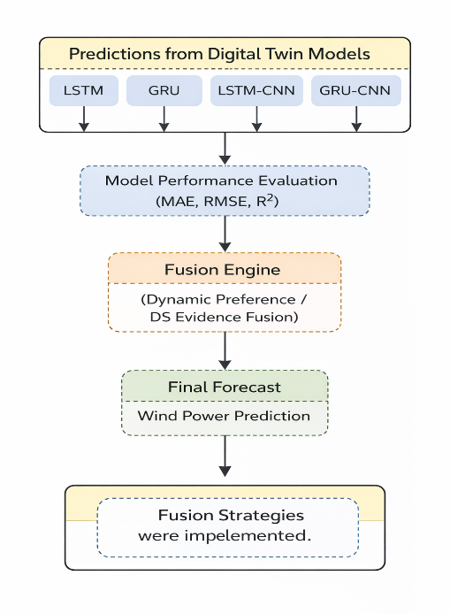
Figure 2.7 Multi-Digital Twin fusion process for combining predictions from multiple digital twin models.
2.9 Fusion Algorithms
To combine predictions from multiple digital twin models, two fusion strategies were implemented in this project.
These methods dynamically integrate model predictions based on their performance.
2.9.1 Method 1 – Dynamic Preference Method
The Dynamic Preference method selects the best performing digital twin model based on a predefined performance metric.
In this study, the Root Mean Square Error (RMSE) was used to evaluate the prediction accuracy of each model.
The RMSE metric is defined as:
$$RMSE=\sqrt{\frac{1}{n}\sum_{i=1}^{n}{{\left(y_{i}-\hat{y_{i}}\right)}^{2}}}$$
where
$y_{i}$= actual wind power value
${\hat{y}}_{i}$= predicted value
$n$= number of observations
The model with the lowest RMSE within a specific time window is selected as the preferred digital twin.
Advantages of Dynamic Preference Method
- Simple implementation
- Adaptive model selection
- Low computational complexity
However, this method relies on a single evaluation metric and may not fully capture model performance in all scenarios.

2.9.2 Method 2 – Dempster-Shafer Evidence Fusion
The second fusion strategy uses Dempster-Shafer evidence theory to combine predictions from multiple models.
Unlike the dynamic preference method, this approach evaluates model performance using multiple metrics, including:
- Mean Absolute Error (MAE) : Mean Absolute Error (MAE) measures the average magnitude of errors between predicted values and actual values. It calculates the absolute difference between the predicted output and the true value for each observation. MAE provides a straightforward measure of prediction accuracy without considering the direction of the error.
$$MAE=\frac{1}{n}\sum_{i=1}^{n}{\left|y_{i}-\hat{y_{i}}\right|}$$Where:
$y_{i}$= actual wind power value
${\hat{y}}_{i}$= predicted wind power value
$n$= total number of observations
- Root Mean Square Error (RMSE) : Root Mean Square Error (RMSE) is another commonly used evaluation metric for regression models. It measures the square root of the average squared differences between predicted values and actual values. RMSE penalizes large errors more heavily than MAE, making it sensitive to significant prediction deviations.
$$RMSE=\sqrt{\frac{1}{n}\sum_{i=1}^{n}{{\left(y_{i}-\hat{y_{i}}\right)}^{2}}}$$Where:
$y_{i}$= actual wind power value
${\hat{y}}_{i}$= predicted wind power value
$n$= total number of observations
- Coefficient of Determination ($R^{2}$) : The coefficient of determination, denoted as $R^{2}$, measures how well the predicted values explain the variability of the actual data. It represents the proportion of variance in the dependent variable that is predictable from the independent variables. A value of $R^{2}$closer to 1 indicates better model performance.
$$R^{2}=1-\frac{\sum_{i=1}^{n}{{\left(y_{i}-\hat{y_{i}}\right)}^{2}}}{\sum_{i=1}^{n}{{\left(y_{i}-\overline{y}\right)}^{2}}}$$Where:
$y_{i}$= actual value
${\hat{y}}_{i}$= predicted value
$\overset{ˉ}{y}$= mean of actual values
Each digital twin model is assigned a weight based on its performance across these metrics.
The final prediction is calculated as a weighted combination of the predictions from all models:
$$P_{final}=\sum_{i=1}^{n}{w_{i}P_{i}}$$
where
$P_{i}$= prediction from digital twin model $i$
$w_{i}$= weight assigned to model $i$
The weights represent the confidence level of each model based on its forecasting accuracy.
By combining multiple models using weighted fusion, the MDT framework can improve prediction reliability and adapt to changing wind conditions.
2.10 Software Implementation
The system was implemented using Python and several scientific computing libraries.
Tool | Purpose
Python | Programming language
NumPy | Numerical computation
Pandas | Data manipulation
PyTorch | Deep learning models
Matplotlib | Data visualization
The source code and implementation are available in the GitHub repository:
Multi-Digital-Twin-Wind-Forecasting-DS-Fusion
The implementation of the MDT framework is organized in a modular structure to maintain code clarity and scalability.
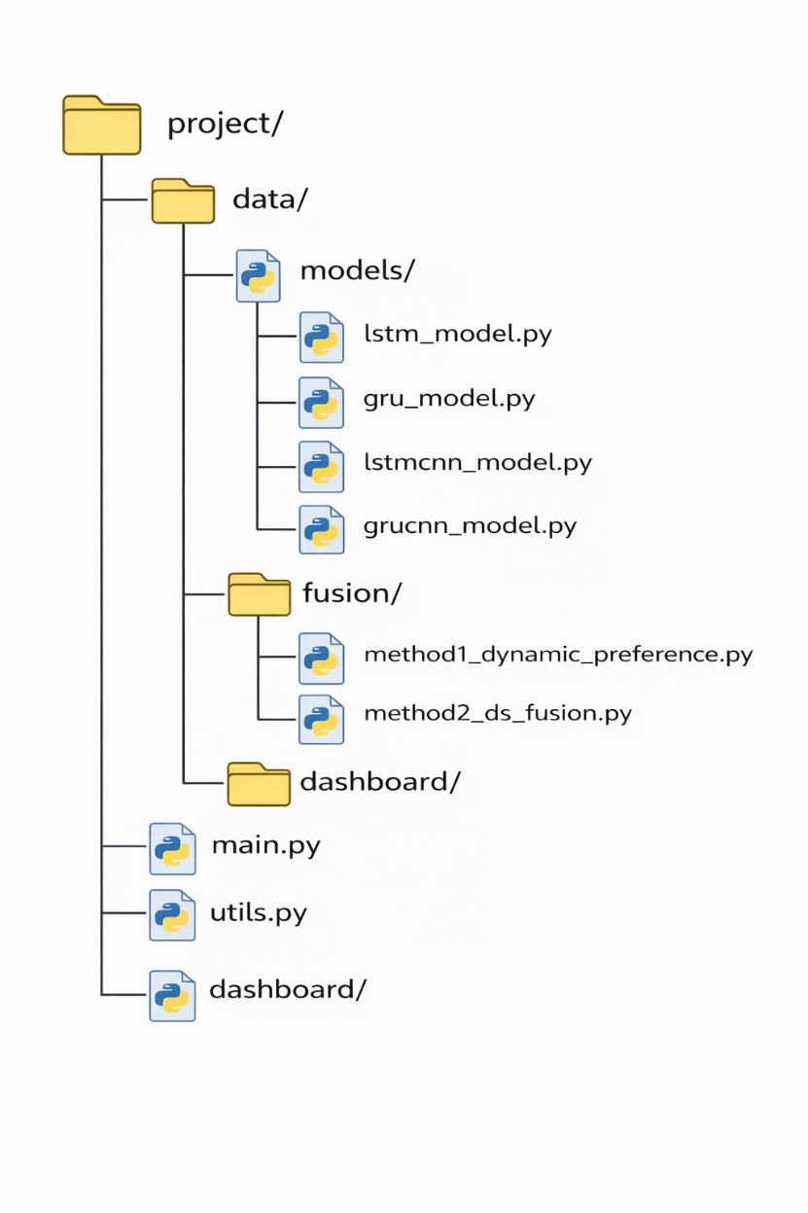
2.11 MDT Visualization Dashboard
To analyze forecasting results, an interactive dashboard was developed.
The dashboard displays:
- predictions from digital twin models
- fusion model results
- performance metrics
- dynamic model weights
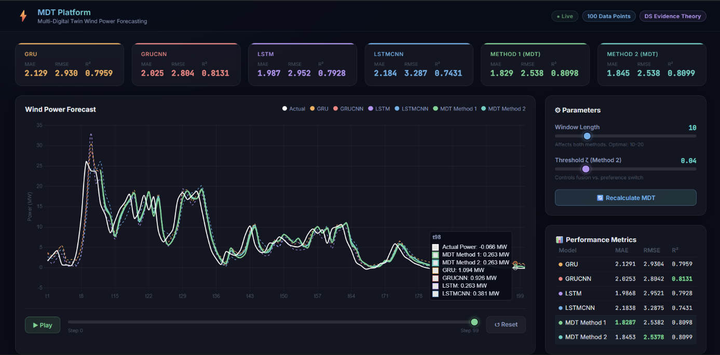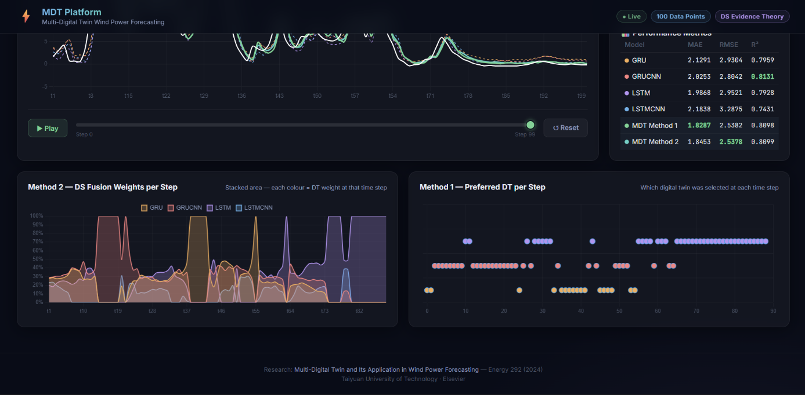
Figure 2.8 and 2.9 MDT forecasting dashboard interface

CHAPTER 3: EXPERIMENTAL RESULTS AND DISCUSSIONS
3.1 Experimental Setup
In this research, experiments were conducted to evaluate the performance of the proposed Multi-Digital Twin (MDT) framework for wind power forecasting. The experiments were performed using real wind farm datasets containing meteorological and operational measurements.
The dataset includes parameters such as:
- Wind speed at different heights
- Temperature
- Humidity
- Air pressure
- Actual wind power generation
The data was sampled every 15 minutes and divided into three subsets:
Dataset | Percentage
Training Set | 81%
Validation Set | 9%
Test Set | 10%

The experiments used four deep learning models acting as digital twins:
- LSTM
- GRU
- LSTM-CNN
- GRU-CNN
These models process historical wind data and generate power forecasts.
The models were implemented using PyTorch framework and evaluated using three performance metrics:
- Mean Absolute Error (MAE)
- Root Mean Square Error (RMSE)
- Coefficient of Determination (R²)
These metrics are widely used for evaluating time-series forecasting accuracy.
3.2 Single Digital Twin Model Results
The performance of individual digital twin models was first evaluated before applying the MDT fusion mechanism.
Each model generated wind power forecasts independently, and the predictions were compared with actual power values.
The forecasting curves demonstrate that all models successfully capture the general trend of wind power generation, but the accuracy varies depending on the model.
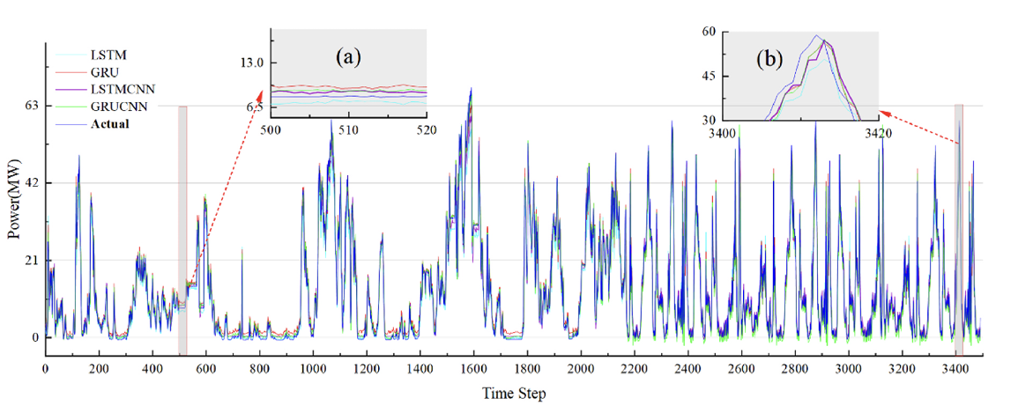
Fig 3.1 Forecasting Results of Single Digital Twin Models
This figure shows the prediction curves of four digital twin models compared with the actual wind power output. The models follow similar patterns but produce different prediction errors during peak generation periods.
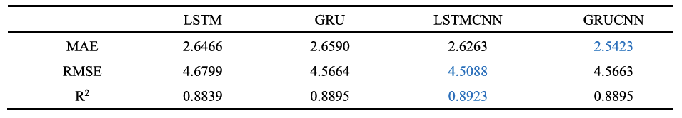
Table 3.1 Single digital twin wind power forecasting metrics.
From the results, it can be observed that:
- LSTM-CNN achieved the best RMSE and R² values
- GRU-CNN achieved the best MAE
This indicates that different models perform better under different evaluation metrics. Therefore, combining multiple digital twins may help improve prediction accuracy.
3.3 Results of Dynamic Preference Fusion Method
In this experiment, the Dynamic Preference Method was used to select the best performing digital twin within a sliding time window.
The model with the lowest RMSE value in the time window was selected as the main digital twin for prediction.
This approach allows the forecasting system to dynamically adapt to changing wind patterns.
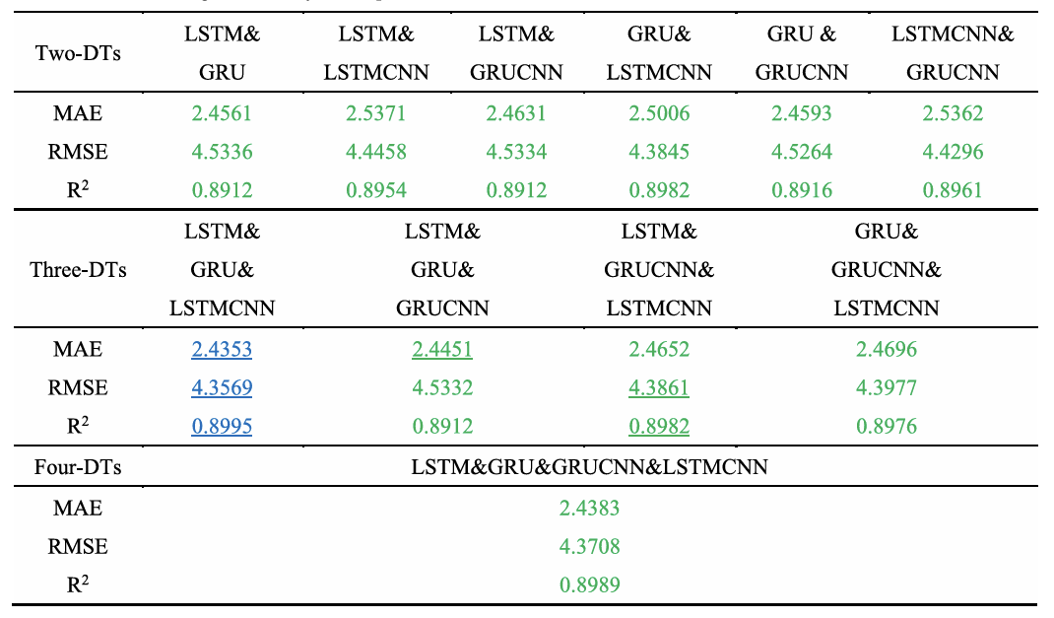
Table 3.2 Test results of the single metric dynamic preference method based on time window.
The results show that the MDT models achieve better forecasting performance compared to single digital twin models. The fusion mechanism effectively utilizes the strengths of different models.
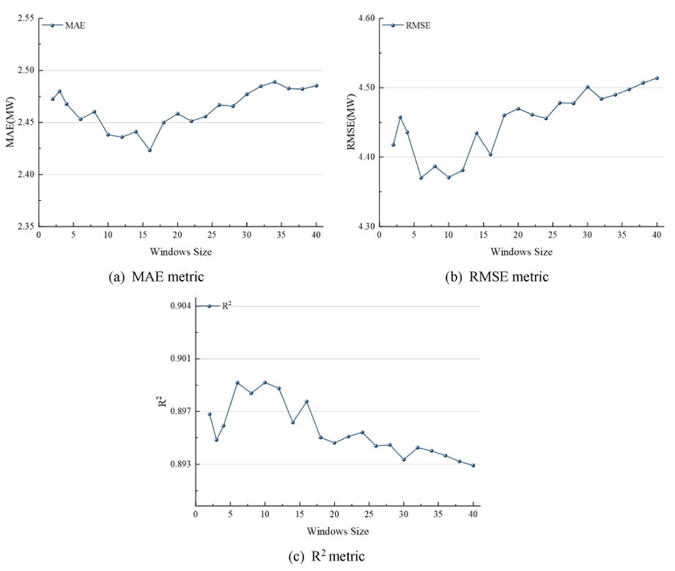
Fig 3.2 Metrics of LSTM&GRU&GRUCNN&LSTMCNN in method 1 with different window lengths.
This figure illustrates how the forecasting performance changes with different window sizes. The results indicate that the optimal window length lies between 5 and 20, where the model achieves the lowest prediction error.
3.4 Results of Multi-Metric Fusion Method
The second experiment applied Dempster-Shafer Evidence Fusion, which combines predictions using multiple performance metrics.
The evaluation metrics considered were:
- MAE
- RMSE
- R²
Each digital twin receives a weight based on these metrics, and the final prediction is computed as a weighted combination.
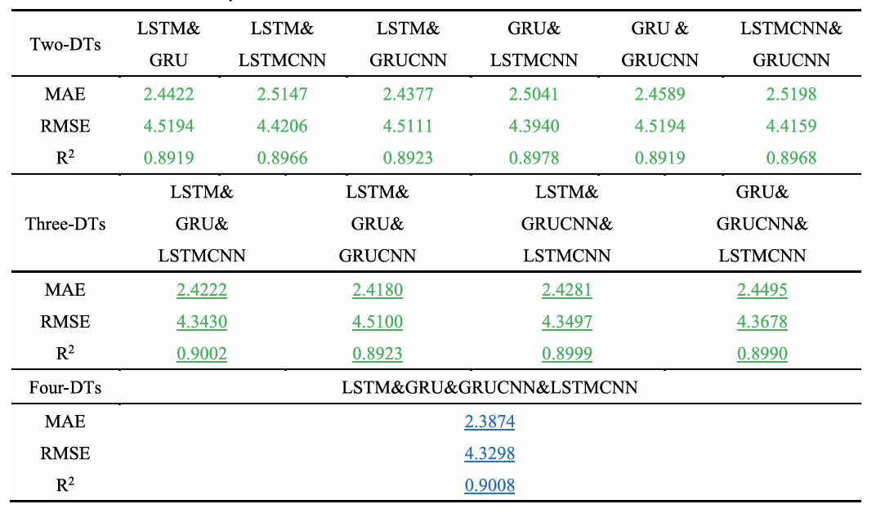
Table 3.3 The multi-metric fusion method achieved better performance compared to the dynamic preference method. This demonstrates the advantage of using multiple evaluation metrics during the fusion process.
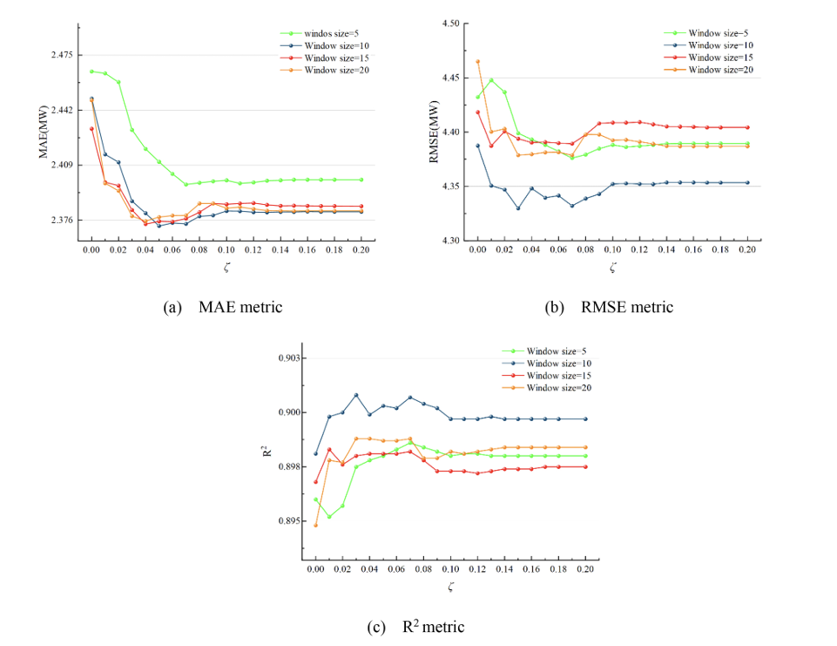
Fig 3.3 The metrics of LSTM&GRU&GRUCNN&LSTMCNN with different threshold ζ and window length in method 2.
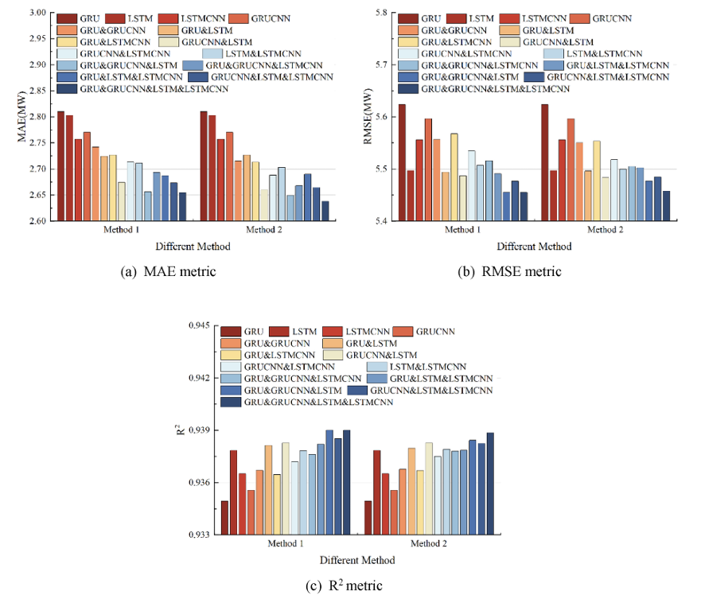
Fig 3.4 Forecasting metrics of single digital twin and MDT under both methods
The figure compares the forecasting performance of individual digital twins and MDT models. It clearly shows that the MDT framework consistently improves prediction accuracy across all evaluation metrics.
3.5 Overall Performance Improvement
To evaluate the improvement of MDT models, the relative improvement of MDT over single digital twins was calculated.
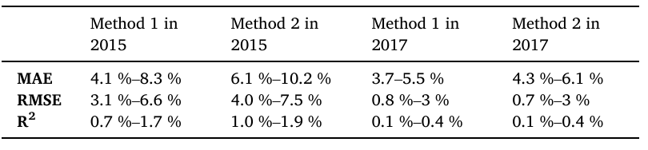
Table 3.4 Relative improvement values of MDT LSTM&GRU&GRUCNN&LSTMCNN compared to the four single digital twins.
The results show that MDT models significantly improve forecasting performance. The most noticeable improvement is observed in the MAE metric, indicating better prediction accuracy.

CHAPTER 4: SUMMARY AND CONCLUSIONS
4.1 Summary of the Work Done
This project presented the design and implementation of a Multi-Digital Twin (MDT) framework for wind power forecasting. The main objective of the project was to improve the accuracy of wind power prediction by combining multiple forecasting models through fusion algorithms within a digital twin environment.
Wind power generation is highly dependent on environmental conditions such as wind speed, temperature, humidity, and atmospheric pressure. Due to the stochastic and intermittent nature of wind, accurate forecasting remains a challenging problem for power system operation and energy management. To address this challenge, this project implemented a multi-model digital twin architecture that integrates multiple deep learning forecasting models and combines their predictions using dynamic fusion strategies.
In this project, four neural network based forecasting models were implemented:
- Long Short-Term Memory Network (LSTM)
- Gated Recurrent Unit (GRU)
- Hybrid LSTM-CNN model
- Hybrid GRU-CNN model
Each of these models acts as an independent digital twin, representing a virtual forecasting agent capable of predicting wind power generation using historical time-series data.
The forecasting models were trained using meteorological and wind power datasets. Input features included parameters such as wind speed at multiple heights, temperature, humidity, pressure, and historical power output. These models were then integrated into a Digital Twin Pool, where multiple models operate simultaneously and generate independent forecasts.
To improve prediction accuracy, two fusion mechanisms were implemented:
- Dynamic Preference Method
  - Selects the best performing digital twin based on RMSE within a time window.
- Multi-Metric Fusion Method (Dempster–Shafer Evidence Theory)
  - Combines predictions using multiple evaluation metrics such as MAE, RMSE, and R².
These fusion methods allow the system to dynamically adapt to changing wind conditions and select or combine the most reliable models.
In addition to the forecasting system, an interactive visualization dashboard was developed to monitor wind power predictions and model performance. The dashboard allows users to view forecasting results, model metrics, and prediction comparisons in real time.
The system architecture consists of:
- Data preprocessing module
- Digital twin forecasting models
- Fusion algorithm module
- Prediction output system
- Visualization dashboard
The results of the experiments demonstrated that the Multi-Digital Twin framework significantly improves forecasting performance compared to individual models. By combining predictions from multiple models, the system reduces forecasting errors and increases overall prediction stability.
4.2 Conclusions
Based on the implementation and experimental evaluation of the proposed system, the following conclusions can be drawn:
- Multi-Digital Twin frameworks improve forecasting accuracy
The integration of multiple digital twins allows the system to leverage the strengths of different models. Experimental results show that the MDT approach produces more accurate predictions than individual forecasting models.
- Fusion algorithms enhance model robustness
The use of fusion algorithms enables the system to dynamically select or combine model outputs based on performance metrics. This improves the reliability of predictions under varying environmental conditions.
- Hybrid neural network models provide better feature extraction
Hybrid models such as LSTM-CNN and GRU-CNN demonstrate improved ability to capture both temporal and spatial patterns in wind power data. These models perform better in complex forecasting scenarios.
- Digital twin technology provides a powerful framework for energy systems
The digital twin concept allows the creation of virtual representations of physical energy systems. This enables simulation, monitoring, and prediction capabilities that are useful for renewable energy management.
- Multi-model forecasting reduces prediction uncertainty
By combining multiple forecasting models, the MDT system reduces the impact of individual model weaknesses and improves prediction stability.
4.3 Limitations of the Study
Although the proposed system demonstrates promising results, several limitations remain:
1. Limited dataset availability
The experiments were conducted using a specific dataset with limited temporal and spatial coverage. Larger and more diverse datasets may further improve model performance.
2. Absence of real-time deployment
The current implementation is primarily designed for offline experiments and simulations. Real-time deployment in operational wind farms requires further system integration.
3. Computational complexity of fusion algorithms
The fusion process introduces additional computational overhead, especially when multiple models are evaluated simultaneously.
4. Model scalability
As the number of digital twins increases, managing model synchronization and computational resources becomes more challenging.

4.4 Future Work
Several directions for future research can further enhance the proposed system:
1. Real-time wind turbine data integration
Future work may focus on integrating real-time data streams from wind turbines and meteorological sensors to enable live forecasting.
2. Deployment on cloud-based digital twin platforms
Cloud computing platforms can be used to scale the MDT system and support large-scale renewable energy monitoring.
3. Reinforcement learning for model optimization
Reinforcement learning techniques can be applied to dynamically adjust model weights and improve forecasting performance over time.
4. Integration with smart grid systems
The MDT framework can be integrated with smart grid infrastructure to support advanced energy management and demand-response systems.
5. Advanced deep learning architectures
Future research may explore transformer-based time series models and attention mechanisms to improve forecasting accuracy.

REFERENCES
[1] S. Liu, J. Tian, Z. Ji, Y. Dai, H. Guo, and S. Yang,
“Research on Multi-Digital Twin and Its Application in Wind Power Forecasting,” Energy, vol. 292, 2024.
[2] F. Tao and Q. Qi,
“Digital Twin Modeling,” Journal of Manufacturing Systems, vol. 64, pp. 372–389, 2022..
[3] S. Hochreiter and J. Schmidhuber,
“Long Short-Term Memory,” Neural Computation, vol. 9, no. 8, pp. 1735–1780, 1997.
[4] R. Dey and F. M. Salem,
“Gate Variants of Gated Recurrent Unit Neural Networks,” in Proceedings of the IEEE 60th International Midwest Symposium on Circuits and Systems, Boston, MA, USA, 2017, pp. 1597–1600.
APPENDIX
Appendix A – GitHub Project Structure
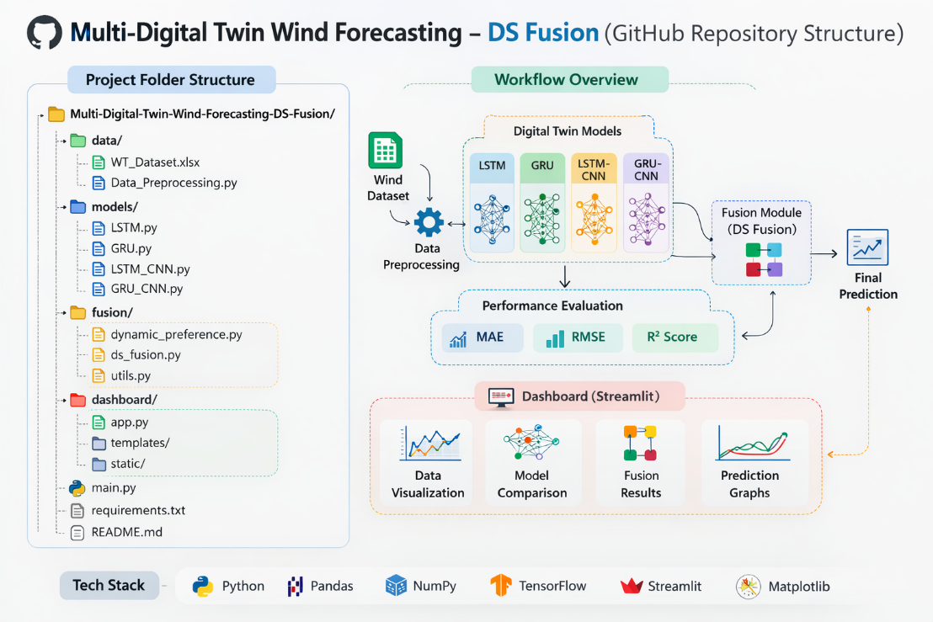
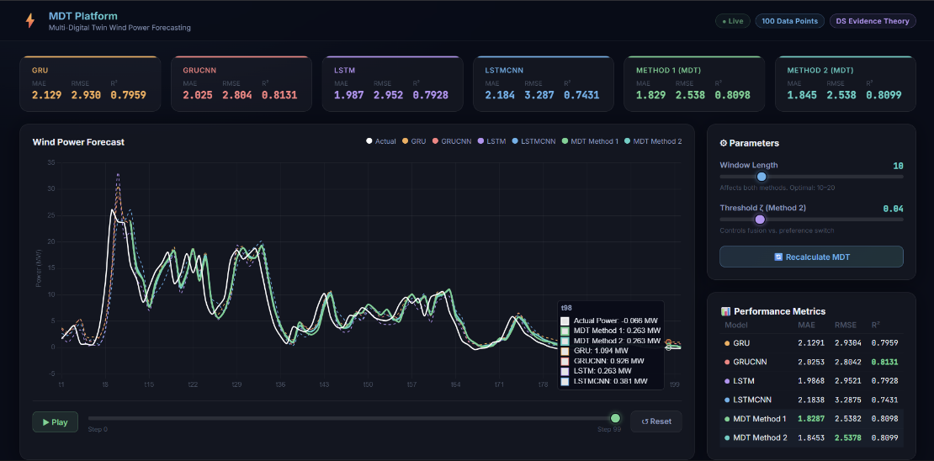
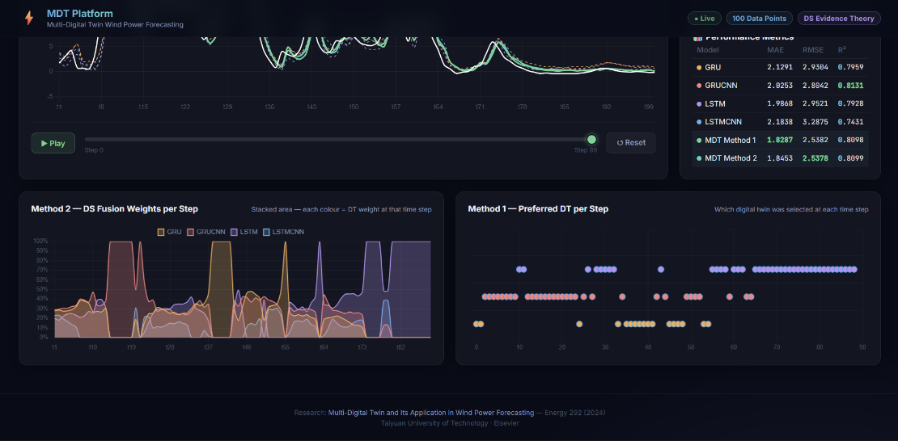
Figure A1: Project Folder Structure of Multi-Digital Twin Forecasting System and Dashboard
Appendix B – Model Hyperparameters

Model | Layers | Hidden Units | Learning Rate | Batch Size
LSTM | 3 | 10 | 0.01 | 64
GRU | 3 | 10 | 0.01 | 64
LSTM-CNN | 1 LSTM + CNN | 16 | 0.01 | 64
GRU-CNN | 1 GRU + CNN | 16 | 0.01 | 64
Table B1: Hyperparameters Used for Digital Twin Models

